**THÊM – XÓA – SỬA – LISTVIEW**

1. **Thêm cách 1**
2. **DEMO APP Thêm bằng menu**

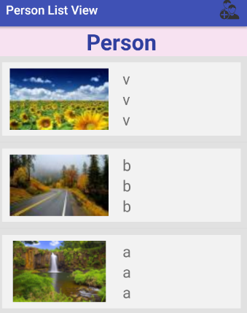 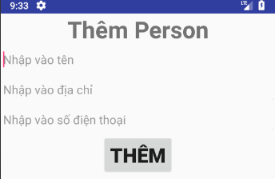

1. **Nhánh thư mục**

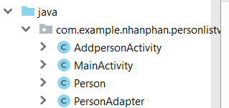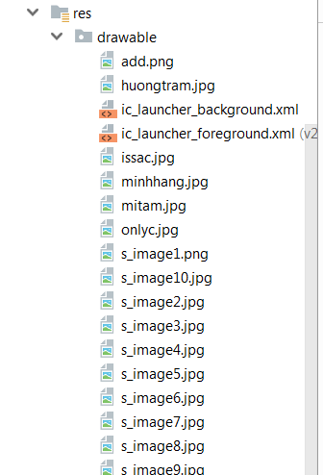

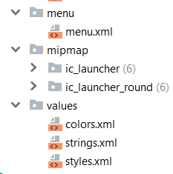 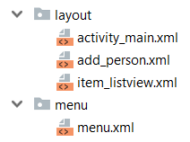

1. **Menu**

 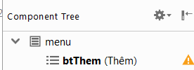

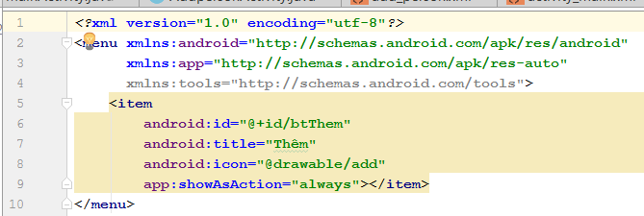

1. **GUI**
2. **Activity_main.xml**

* **Layout**

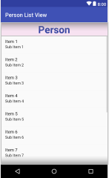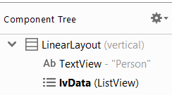

* **Code**

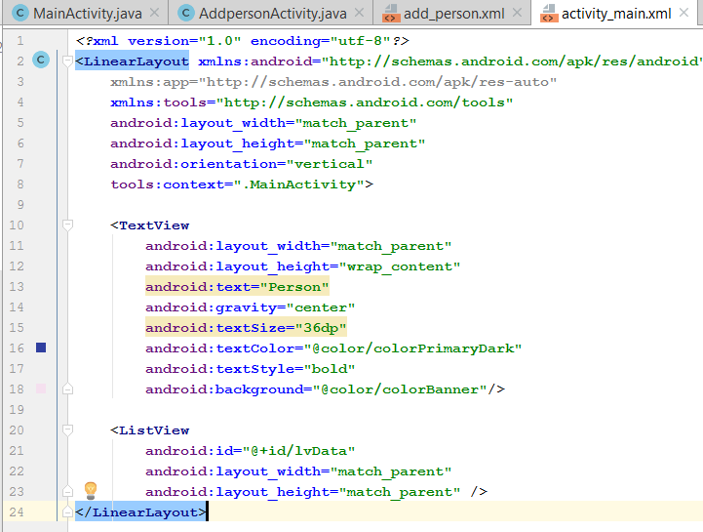

1. **Item_listView**

* **Layout**

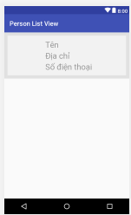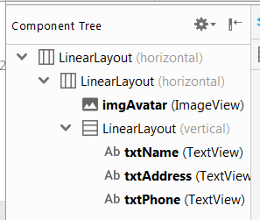

* **Code**

|  |
| --- |
| *<?***xml version="1.0" encoding="utf-8"***?>* <**LinearLayout xmlns:android="http://schemas.android.com/apk/res/android"  android:layout_width="match_parent"  android:layout_height="wrap_content"  android:background="#e1e1e1"  android:orientation="horizontal"  android:padding="10dp"**>  <**LinearLayout  android:layout_width="match_parent"  android:layout_height="match_parent"  android:background="#f2f2f2"**>  <**ImageView  android:id="@+id/imgAvatar"  android:layout_width="wrap_content"  android:layout_height="match_parent"  android:layout_weight="1"  android:padding="10dp"** />  <**LinearLayout  android:layout_width="0dp"  android:layout_height="wrap_content"  android:layout_weight="3"  android:orientation="vertical"  android:padding="10dp"**>  <**TextView  android:id="@+id/txtName"  android:layout_width="match_parent"  android:layout_height="wrap_content"  android:hint="Tên"  android:textSize="25sp"** />  <**TextView  android:id="@+id/txtAddress"  android:layout_width="match_parent"  android:layout_height="wrap_content"  android:hint="Địa chỉ"  android:textSize="25sp"** />  <**TextView  android:id="@+id/txtPhone"  android:layout_width="match_parent"  android:layout_height="wrap_content"  android:hint="Số điện thoại"  android:textSize="25sp"** />  </**LinearLayout**>  </**LinearLayout**> </**LinearLayout**> |

1. **Add_person.xml**

* **Layout**

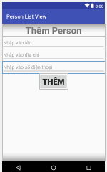 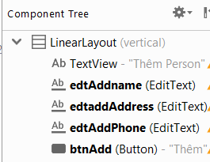

* **Code**

|  |
| --- |
| *<?***xml version="1.0" encoding="utf-8"***?>* <**LinearLayout xmlns:android="http://schemas.android.com/apk/res/android"  android:layout_width="match_parent"  android:layout_height="match_parent"  android:gravity="center_horizontal"  android:orientation="vertical"**>  <**TextView  android:layout_width="match_parent"  android:layout_height="wrap_content"  android:gravity="center"  android:text="Thêm Person"  android:textSize="35sp"  android:textStyle="bold"** />  <**EditText  android:id="@+id/edtAddname"  android:layout_width="match_parent"  android:layout_height="wrap_content"  android:hint="Nhập vào tên"** />  <**EditText  android:id="@+id/edtaddAddress"  android:layout_width="match_parent"  android:layout_height="wrap_content"  android:hint="Nhập vào địa chỉ"** />  <**EditText  android:id="@+id/edtAddPhone"  android:layout_width="match_parent"  android:layout_height="wrap_content"  android:hint="Nhập vào số điện thoại"** />  <**Button  android:id="@+id/btnAdd"  android:layout_width="wrap_content"  android:layout_height="wrap_content"  android:text="Thêm"  android:textSize="30sp"  android:textStyle="bold"** /> </**LinearLayout**> |

1. **CODE**
2. **Person – class**

|  |
| --- |
| **package** com.example.nhanphan.personlistview;  **import** java.io.Serializable;  **public class** Person **implements** Serializable {  **int code**;  **private int avatar**;  **private** String **name**;  **private** String **address**;  **private** String **phone**;   **public** Person() { }  **public** Person(**int** code, **int** avatar, String name, String address, String phone) {  **this**.**code** = code;  **this**.**avatar** = avatar;  **this**.**name** = name;  **this**.**address** = address;  **this**.**phone** = phone;  }  **public int** getCode() {  **return code**;  }  **public void** setCode(**int** code) {  **this**.**code** = code;  }   **public int** getAvatar() {  **return avatar**;  }   **public void** setAvatar(**int** avatar) {  **this**.**avatar** = avatar;  }   **public** String getName() {  **return name**;  }   **public void** setName(String name) {  **this**.**name** = name;  }   **public** String getAddress() {  **return address**;  }   **public void** setAddress(String address) {  **this**.**address** = address;  }   **public** String getPhone() {  **return phone**;  }   **public void** setPhone(String phone) {  **this**.**phone** = phone;  } } |

1. **PersonAdapter – class**

|  |
| --- |
| **package** com.example.nhanphan.personlistview;   **import** android.content.Context; **import** android.view.LayoutInflater; **import** android.view.View; **import** android.view.ViewGroup; **import** android.widget.BaseAdapter; **import** android.widget.ImageView; **import** android.widget.TextView;  **import** java.util.ArrayList;  **public class** PersonAdapter **extends** BaseAdapter {  ArrayList<Person> **listData**;  LayoutInflater **inflater**;  ImageView **imgAvatar**;  TextView **txtName**, **txtAddress**, **txtPhone**;   **public** PersonAdapter(ArrayList<Person> listData, Context context){  **this**.**listData** = listData;  **inflater** = (LayoutInflater) context.getSystemService(context.***LAYOUT_INFLATER_SERVICE***);  }  **public** ArrayList<Person> getListData() {  **return listData**;  }   **public void** setListData(ArrayList<Person> listData) {  **this**.**listData** = listData;  }   @Override  **public int** getCount() {  **return listData**.size();  }   @Override  **public** Person getItem(**int** position) {  **return listData**.get(position);  }   @Override  **public long** getItemId(**int** position) {  **return** 0;  }   @Override  **public** View getView(**int** position, View convertView, ViewGroup parent) {  **if** (convertView == **null**)  convertView = **inflater**.inflate(R.layout.***item_listview***, **null**); *// Gọi và gán layout* **imgAvatar** = (ImageView) convertView.findViewById(R.id.***imgAvatar***);  **txtName** = (TextView) convertView.findViewById(R.id.***txtName***);  **txtAddress** = (TextView) convertView.findViewById(R.id.***txtAddress***);  **txtPhone** = (TextView) convertView.findViewById(R.id.***txtPhone***);   Person person = getItem(position);  **imgAvatar**.setImageResource(person.getAvatar());  **txtName**.setText(person.getName().toString());  **txtAddress**.setText(person.getAddress().toString());  **txtPhone**.setText(person.getPhone().toString());  **return** convertView;  } } |

1. **AddpersonActivity**

|  |
| --- |
| **package** com.example.nhanphan.personlistview;  **import** android.content.Intent; **import** android.support.v7.app.AppCompatActivity; **import** android.os.Bundle; **import** android.view.View; **import** android.widget.Button; **import** android.widget.EditText; **import** android.widget.TextView;  **public class** AddpersonActivity **extends** AppCompatActivity {  TextView **edtAddName**, **edtAddAddress**, **edtAddphone**;  Button **btnAdd**;  **int pos**;  Integer[] **Hinhnho** = {R.drawable.***s_image1***,R.drawable.***s_image2***,R.drawable.***s_image3***,R.drawable.***s_image4***,  R.drawable.***s_image5***,R.drawable.***s_image6***,R.drawable.***s_image7***,R.drawable.***s_image8***,R.drawable.***s_image9***};  @Override  **protected void** onCreate(Bundle savedInstanceState) {  **super**.onCreate(savedInstanceState);  setContentView(R.layout.***add_person***); *// thay layout* getSupportActionBar().hide();  Intent intent = getIntent();  **pos** = intent.getIntExtra(**"pos"**,0);  initview();  }  **public void** initview(){  **edtAddName** = (EditText) findViewById(R.id.***edtAddname***);  **edtAddAddress** = (TextView) findViewById(R.id.***edtaddAddress***);  **edtAddphone** = (TextView) findViewById(R.id.***edtAddPhone***);  **btnAdd** = (Button) findViewById(R.id.***btnAdd***);  **btnAdd**.setOnClickListener(**new** View.OnClickListener() {  @Override  **public void** onClick(View v) {  Person person = **new** Person(**pos**, **Hinhnho**[**pos**++], **edtAddName**.getText().toString(),  **edtAddAddress**.getText().toString(), **edtAddphone**.getText().toString());  Intent intent = **new** Intent(AddpersonActivity.**this**, MainActivity.**class**);  intent.putExtra(**"ADD"**,person);  setResult(100, intent);  finish();  }  });  }  } |

1. **MainACtivity**

|  |
| --- |
| **package** com.example.nhanphan.personlistview;  **import** android.content.Intent; **import** android.support.v7.app.AppCompatActivity; **import** android.os.Bundle; **import** android.view.Menu; **import** android.view.MenuItem; **import** android.view.View; **import** android.widget.AdapterView; **import** android.widget.GridView; **import** android.widget.ImageView; **import** android.widget.ListView; **import** android.widget.Toast;  **import** java.util.ArrayList; **import** java.util.MissingFormatArgumentException; **import** java.util.zip.Inflater;  **public class** MainActivity **extends** AppCompatActivity {   PersonAdapter **adapter**;  ArrayList<Person> **listData**;  ListView **lvData**;  ImageView **imgAddPerson**;  **int pos**=0;  @Override  **protected void** onCreate(Bundle savedInstanceState) {  **super**.onCreate(savedInstanceState);  setContentView(R.layout.***activity_main***);  *//getSupportActionBar().hide();  // Gọi phương thức getData và initView* getData();  initView();  }   **private void** initView() {  **adapter** = **new** PersonAdapter(**listData**, MainActivity.**this**);  **lvData** = (ListView) findViewById(R.id.***lvData***);  **lvData**.setAdapter(**adapter**);  **adapter**.notifyDataSetChanged();   *// imgAddPerson = (ImageView) findViewById(R.id.imgAddPerson);* }   **private void** getData() {  **listData** = **new** ArrayList<>();   }    @Override  **protected void** onActivityResult(**int** requestCode, **int** resultCode, Intent data) {  **switch** (requestCode){  **case** 10:  **if** (data != **null**){  Person person = (Person) data.getSerializableExtra(**"ADD"**);  **if** (resultCode == 100){  person.setCode(**adapter**.getCount() + 1);  **adapter**.getListData().add(0,person);  **adapter**.notifyDataSetChanged();  Toast.*makeText*(MainActivity.**this**, **"Thêm thành công!"**, Toast.***LENGTH_SHORT***).show();  }**else** {  Toast.*makeText*(MainActivity.**this**, **"Có lỗi xảy ra, vui lòng thử lại!"**, Toast.***LENGTH_SHORT***).show();  }  **break**;  }  **case** 20:  **if** (data != **null**){  Person seclect = (Person) data.getSerializableExtra(**"EDIT"**);  **if** (resultCode == 200){  **for** (Person item:**adapter**.getListData()){  **if** (item.getCode() == seclect.getCode()){  item.setAvatar(seclect.getCode());  item.setName(seclect.getName());  item.setAddress(seclect.getAddress());  item.setPhone(seclect.getPhone());  **break**;  }  }  **adapter**.notifyDataSetChanged();  **break**;  }**else if** (resultCode == 300){  **int** ID = data.getExtras().getInt(**"DEL"**);  **int** position = -1;  **for** (**int** i = 0; i < **adapter**.getCount(); i++){  **if** (**adapter**.getItem(i).getCode() == ID){  position = i;  **break**;  }  }  **if** (position < 10){  Toast.*makeText*(MainActivity.**this**,**"Không xác định được vị trí"**, Toast.***LENGTH_SHORT***).show();  }**else** {  **adapter**.getListData().remove(position);  **adapter**.notifyDataSetChanged();  Toast.*makeText*(MainActivity.**this**, **"Đã xóa thành công!"**, Toast.***LENGTH_SHORT***).show();  }  }  }  }  *// super.onActivityResult(requestCode, resultCode, data);* }  *//* @Override  **public boolean** onCreateOptionsMenu(Menu menu) {  getMenuInflater().inflate(R.menu.***menu***,menu);  **return super**.onCreateOptionsMenu(menu);  }   @Override  **public boolean** onOptionsItemSelected(MenuItem item) {  **int** id = item.getItemId();  **if** (id == R.id.***btThem***){  Intent inte = **new** Intent(MainActivity.**this**, AddpersonActivity.**class**);  inte.putExtra(**"pos"**, **pos**++);  startActivityForResult(inte, 10);  }  **return super**.onOptionsItemSelected(item);  } } |

1. **Sửa và xóa**
2. **Demo Sửa**

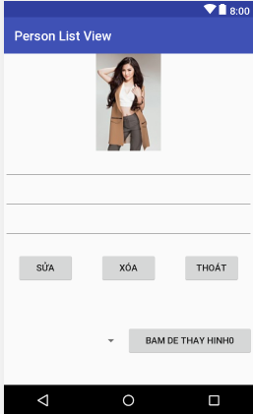

1. **Nhánh thư mục**
2. **GUI**

**Layout Edit:**

*<?***xml version="1.0" encoding="utf-8"***?>*<**LinearLayout xmlns:android="http://schemas.android.com/apk/res/android"  
 xmlns:tools="http://schemas.android.com/tools"  
 android:orientation="vertical"  
 android:gravity="center_horizontal"  
 android:layout_width="match_parent"  
 android:layout_height="match_parent"  
  
 tools:context="com.example.nhanphan.personlistview.EditActivity2"**>  
 <**ImageView  
 android:id="@+id/imgEditAvatar"  
 android:src="@drawable/huongtram"  
 android:layout_width="wrap_content"  
 android:layout_height="wrap_content"** />  
 <**EditText  
 android:id="@+id/edtEditName"  
 android:layout_width="match_parent"  
 android:layout_height="wrap_content"** />  
 <**EditText  
 android:id="@+id/edtEditAddress"  
 android:layout_width="match_parent"  
 android:layout_height="wrap_content"** />  
 <**EditText  
 android:id="@+id/edtEditPhone"  
 android:layout_width="match_parent"  
 android:layout_height="wrap_content"** />  
 <**LinearLayout  
 android:orientation="horizontal"  
 android:layout_width="match_parent"  
 android:layout_height="wrap_content"**>  
 <**Button  
 android:id="@+id/btnEdit"  
 android:text="Sửa"  
 android:layout_margin="20dp"  
 android:layout_weight="1"  
 android:layout_width="0dp"  
 android:layout_height="wrap_content"** />  
 <**Button  
 android:id="@+id/btnDel"  
 android:text="Xóa"  
 android:layout_margin="20dp"  
 android:layout_weight="1"  
 android:layout_width="0dp"  
 android:layout_height="wrap_content"** />  
 <**Button  
 android:id="@+id/btnExitEdit"  
 android:text="Thoát"  
 android:layout_margin="20dp"  
 android:layout_weight="1"  
 android:layout_width="0dp"  
 android:layout_height="wrap_content"** />  
  
 </**LinearLayout**>  
  
 <**LinearLayout  
 android:layout_width="match_parent"  
 android:layout_height="match_parent"  
 android:orientation="horizontal"**>  
  
 <**Spinner  
 android:id="@+id/spin"  
 android:layout_width="100dp"  
 android:layout_height="100dp"  
 android:layout_gravity="center"  
 android:layout_weight="1"**>  
  
 </**Spinner**>  
  
 <**Button  
 android:id="@+id/buttonThem"  
 android:layout_width="106dp"  
 android:layout_height="wrap_content"  
 android:layout_gravity="center"  
 android:layout_weight="1"  
 android:text="Bam de thay hinh0"** />  
 </**LinearLayout**>  
</**LinearLayout**>

1. **Code Activity Edit**
2. **package** com.example.nhanphan.personlistview;  
     
   **import** android.content.Intent;  
   **import** android.support.v7.app.AppCompatActivity;  
   **import** android.os.Bundle;  
   **import** android.view.View;  
   **import** android.widget.AdapterView;  
   **import** android.widget.Button;  
   **import** android.widget.EditText;  
   **import** android.widget.ImageView;  
   **import** android.widget.Spinner;  
     
   **public class** EditActivity2 **extends** AppCompatActivity {  
     
    ImageView **imgEditAvatar**;  
    EditText **edtEditName**, **edtEditAddress**, **edtEditPhone**;  
    Button **btnSaveEdit**, **btnExitEdit**, **btnDel** ,**btLay**;  
    Person **person**;  
    **int path**;  
     
    Spinner **spinner**;  
    **int**[] **Hinhnho** = {R.drawable.***s_image1***,R.drawable.***s_image2***,R.drawable.***s_image3***,R.drawable.***s_image4***,  
    R.drawable.***s_image5***,R.drawable.***s_image6***,R.drawable.***s_image7***,R.drawable.***s_image8***,R.drawable.***s_image9***};  
    **int pathImg**;  
    @Override  
    **protected void** onCreate(Bundle savedInstanceState) {  
    **super**.onCreate(savedInstanceState);  
    setContentView(R.layout.***activity_edit2***);  
    **imgEditAvatar** = (ImageView) findViewById(R.id.***imgEditAvatar***);  
    **btLay**= (Button) findViewById(R.id.***buttonThem***);  
    *// Gọi phương thức ivitView và getData* **spinner** =(Spinner) findViewById(R.id.***spin***);  
    CustomAdapterSpinner customAdapterSpinner = **new** CustomAdapterSpinner(EditActivity2.**this**,R.layout.***spinner_layout***,**Hinhnho**);  
    **spinner**.setAdapter(customAdapterSpinner);  
    **spinner**.setOnItemSelectedListener(**new** AdapterView.OnItemSelectedListener() {  
    @Override  
    **public void** onItemSelected(AdapterView<?> parent, View view, **int** position, **long** id) {  
     
    **pathImg** = **spinner**.getSelectedItemPosition();  
     
    }  
     
    @Override  
    **public void** onNothingSelected(AdapterView<?> parent) {  
    }  
    });  
    **btLay**.setOnClickListener(**new** View.OnClickListener() {  
    @Override  
    **public void** onClick(View view) {  
    **imgEditAvatar**.setImageResource(**Hinhnho**[**pathImg**]);  
    }  
    });  
     
    initView();  
    getData();  
    }  
    *// Khởi tạo initView* **private void** initView() {  
     
     
     
    **edtEditName** = (EditText) findViewById(R.id.***edtEditName***);  
    **edtEditAddress** = (EditText) findViewById(R.id.***edtEditAddress***);  
    **edtEditPhone** = (EditText) findViewById(R.id.***edtEditPhone***);  
    **btnExitEdit** = (Button) findViewById(R.id.***btnExitEdit***);  
    **btnSaveEdit** = (Button) findViewById(R.id.***btnEdit***);  
    **btnDel** = (Button) findViewById(R.id.***btnDel***);  
    **btnSaveEdit**.setOnClickListener(**SaveEdit_Click**);  
    **btnExitEdit**.setOnClickListener(**Exit_Edit**);  
    **btnDel**.setOnClickListener(**Del_Click**);  
    }  
     
    *// Khơi tạo getData* **private void** getData() {  
    **if** (getIntent().getExtras() != **null**) {  
    **person** = (Person) getIntent().getSerializableExtra(**"EDIT"**);  
    **int** a = **person**.getCode();  
    **imgEditAvatar**.setImageResource(**person**.getAvatar());  
    **edtEditName**.setText(**person**.getName());  
    **edtEditAddress**.setText(**person**.getAddress());  
    **edtEditPhone**.setText(**person**.getPhone());  
    }  
    }  
     
    View.OnClickListener **SaveEdit_Click** = **new** View.OnClickListener() {  
    @Override  
    **public void** onClick(View v) {  
    Intent intent = **new** Intent(EditActivity2.**this**, MainActivity.**class**);  
    **int** b = **person**.getCode();  
     
     
     
    *//adapter = new PersonAdapter(new ArrayAdapter<String>(list, EditActivity.this);  
    //ArrayAdapter<String> list = new ArrayAdapter<String>(this, android.R.layout.simple_spinner_dropdown_item, Hinhnho);  
    //spinner.setAdapter(list);* Person person1 = **new** Person(b, **Hinhnho**[**pathImg**],  
    **edtEditName**.getText().toString(), **edtEditAddress**.getText().toString(), **edtEditPhone**.getText().toString());  
    intent.putExtra(**"EDIT"**, person1);  
    setResult(200, intent);  
    finish();  
    }  
    };  
    View.OnClickListener **Del_Click** = **new** View.OnClickListener() {  
    @Override  
    **public void** onClick(View v) {  
    Intent intent = **new** Intent(EditActivity2.**this**, MainActivity.**class**);  
    intent.putExtra(**"DEL"**, **person**.getCode());  
    setResult(300, intent);  
    finish();  
    }  
    };  
    View.OnClickListener **Exit_Edit** = **new** View.OnClickListener() {  
    @Override  
    **public void** onClick(View v) {  
    finish();  
    }  
    };  
   }

**Code Main Activity HoanChinh**

**package** com.example.nhanphan.personlistview;  
  
**import** android.content.Intent;  
**import** android.support.v7.app.AppCompatActivity;  
**import** android.os.Bundle;  
**import** android.view.Menu;  
**import** android.view.MenuItem;  
**import** android.view.View;  
**import** android.widget.AdapterView;  
**import** android.widget.GridView;  
**import** android.widget.ImageView;  
**import** android.widget.ListView;  
**import** android.widget.Toast;  
  
**import** java.util.ArrayList;  
**import** java.util.MissingFormatArgumentException;  
**import** java.util.zip.Inflater;  
  
**public class** MainActivity **extends** AppCompatActivity {  
  
 PersonAdapter **adapter**;  
 ArrayList<Person> **listData**;  
 ListView **lvData**;  
 ImageView **imgAddPerson**;  
 **int pos**=0;  
 @Override  
 **protected void** onCreate(Bundle savedInstanceState) {  
 **super**.onCreate(savedInstanceState);  
 setContentView(R.layout.***activity_main***);  
 *//getSupportActionBar().hide();  
 // Gọi phương thức getData và initView* getData();  
 initView();  
 }  
 View.OnClickListener **Add_Click** = **new** View.OnClickListener() { *// Cách 2* @Override  
 **public void** onClick(View v) {  
 Intent inte = **new** Intent(MainActivity.**this**, ActivityAddPerson.**class**);  
 inte.putExtra(**"pos"**, **pos**++);  
 startActivityForResult(inte, 10);  
 }  
 };  
 **private void** initView() {  
 **adapter** = **new** PersonAdapter(**listData**, MainActivity.**this**);  
 **lvData** = (ListView) findViewById(R.id.***lvData***);  
 **lvData**.setAdapter(**adapter**);  
 **adapter**.notifyDataSetChanged();  
 **imgAddPerson** = (ImageView) findViewById(R.id.***imgAddPerson***); *// Cách 2* **imgAddPerson**.setOnClickListener(**Add_Click**); *// Cách 2  
 // Sửa* **lvData**.setOnItemClickListener(**new** AdapterView.OnItemClickListener() {  
 @Override  
 **public void** onItemClick(AdapterView<?> adapterView, View view, **int** i, **long** l) {  
 Intent intent = **new** Intent(MainActivity.**this**, EditActivity2.**class**);  
 intent.putExtra(**"EDIT"**, **adapter**.getItem(i));  
 startActivityForResult(intent, 20);  
 }  
 });  
  
 }  
 **private void** getData() {  
 **listData** = **new** ArrayList<>();  
  
 }  
  
 @Override  
 **protected void** onActivityResult(**int** requestCode, **int** resultCode, Intent data) {  
 **switch** (requestCode){  
 **case** 10:  
 **if** (data != **null**){  
 Person person = (Person) data.getSerializableExtra(**"ADD"**);  
 **if** (resultCode == 100){  
 person.setCode(**adapter**.getCount() + 1);  
 **adapter**.getListData().add(0,person);  
 **adapter**.notifyDataSetChanged();  
 Toast.*makeText*(MainActivity.**this**, **"Thêm thành công!"**, Toast.***LENGTH_SHORT***).show();  
 }**else** {  
 Toast.*makeText*(MainActivity.**this**, **"Có lỗi xảy ra, vui lòng thử lại!"**, Toast.***LENGTH_SHORT***).show();  
 }  
 **break**;  
 }  
 **case** 20:  
 **if** (data != **null**){  
 Person select = (Person) data.getSerializableExtra(**"EDIT"**);  
 **if** (resultCode == 200){  
 **for** (Person item:**adapter**.getListData()){  
 **if** (item.getCode() == select.getCode()){  
 item.setAvatar(select.getAvatar());  
 item.setName(select.getName());  
 item.setAddress(select.getAddress());  
 item.setPhone(select.getPhone());  
 **break**;  
 }  
 }  
 **adapter**.notifyDataSetChanged();  
 **break**;  
 }**else if** (resultCode == 300){  
 **int** ID = data.getExtras().getInt(**"DEL"**);  
 **int** position = -1;  
 **for** (**int** i = 0; i < **adapter**.getCount(); i++){  
 **if** (**adapter**.getItem(i).getCode() == ID){  
 position = i;  
 **break**;  
 }  
 }  
 **if** (position < 0){  
 Toast.*makeText*(MainActivity.**this**,**"Không xác định được vị trí"**, Toast.***LENGTH_SHORT***).show();  
 }**else** {  
 **adapter**.getListData().remove(position);  
 **adapter**.notifyDataSetChanged();  
 Toast.*makeText*(MainActivity.**this**, **"Đã xóa thành công!"**, Toast.***LENGTH_SHORT***).show();  
 }  
 }  
 }  
 }  
  
 *// super.onActivityResult(requestCode, resultCode, data);* }  
 *//* @Override  
 **public boolean** onCreateOptionsMenu(Menu menu) {  
 getMenuInflater().inflate(R.menu.***menu***,menu);  
 **return super**.onCreateOptionsMenu(menu);  
 }  
 @Override  
 **public boolean** onOptionsItemSelected(MenuItem item) {  
 **int** id = item.getItemId();  
 **if** (id == R.id.***btThem***){  
 Intent inte = **new** Intent(MainActivity.**this**, AddpersonActivity.**class**);  
 inte.putExtra(**"pos"**, **pos**++);  
 startActivityForResult(inte, 10);  
 }  
 **return super**.onOptionsItemSelected(item);  
 }  
}